INTRODUCTION

Welcome to our Contact Management System, a powerful and user-friendly application built with VB.NET. Our system provides a comprehensive solution for managing your contacts, allowing you to add, edit, delete, and view your contacts with ease. With this application, you can keep track of all your important contacts in one place and stay organized. Whether you are a business owner, a salesperson, or just someone who wants to keep track of your personal contacts, our Contact Management System has got you covered. Let's explore the various features of our application and discover how it can help simplify your contact management process.

Algorithm and Flowchart

Algorithm:

1. Start
2. Display the main menu
3. If the user selects "Add Contact," prompt the user to enter the contact details and save the contact to the database
4. If the user selects "Edit Contact," prompt the user to select the contact to edit and update the contact details in the database
5. If the user selects "Delete Contact," prompt the user to select the contact to delete and remove the contact from the database
6. If the user selects "View Contact," display a list of all contacts in the database
7. If the user selects "Exit," terminate the program
8. If the user selects an invalid option, display an error message and return to the main menu
9. Repeat steps 2-8 until the user chooses to exit the program
10. End

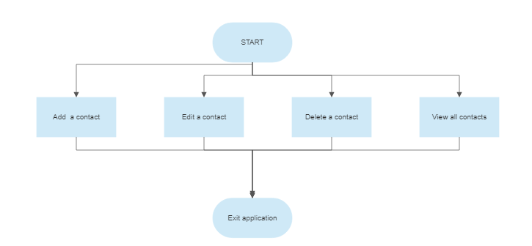

Hardware and Software Requirements

Hardware Requirements:

* Processor: Intel Pentium 4 or higher
* RAM: 2 GB or higher
* Hard Disk: 100 MB of free space or higher
* Display: Minimum resolution of 1024x768 pixels

Software Requirements:

* Operating System: Microsoft Windows 7 or later
* .NET Framework 4.5 or later
* Microsoft Visual Studio 2012 or later

Note: These requirements are only estimates and may vary depending on the size of the database and the number of users accessing the system concurrently. It's always a good idea to consult with a professional to ensure that your hardware and software infrastructure can handle the requirements of your Contact Management System.

Source code

1. Open Microsoft Visual Studio and create a new VB.NET project.
2. Add a new form to the project and design the user interface for your Contact Management System. You can use various controls such as text boxes, buttons, labels, and grids to display and manipulate the contact data.
3. Add a database to your project to store the contact information. You can use Microsoft SQL Server or any other database management system of your choice.
4. Write the code to perform the various operations of your Contact Management System, such as adding, editing, deleting, and viewing contacts. You can use VB.NET's built-in database connectivity libraries or third-party libraries to interact with the database.
5. Test your Contact Management System thoroughly to ensure that it works as expected and handles errors gracefully.

Note: Writing source code for a Contact Management System can be a complex task, especially if you are new to programming. It's always a good idea to seek help from a professional programmer or a community of developers if you face any difficulties.

Output of the code

The output of your Contact Management System code will depend on the specific operations performed by the user. Here are some possible outputs for the different operations:

1. Add Contact:

* If the user enters valid contact details and clicks the "Add" button, the contact will be added to the database, and a success message will be displayed.
* If the user enters invalid or incomplete contact details, an error message will be displayed, and the user will be prompted to correct the input.

1. Edit Contact:

* If the user selects a contact to edit and enters valid contact details, the contact will be updated in the database, and a success message will be displayed.
* If the user enters invalid or incomplete contact details, an error message will be displayed, and the user will be prompted to correct the input.

1. Delete Contact:

* If the user selects a contact to delete and clicks the "Delete" button, the contact will be removed from the database, and a success message will be displayed.
* If the user cancels the deletion or the contact does not exist in the database, a message indicating the failure of the operation will be displayed.

1. View Contact:

* If the user selects the "View Contacts" option, a list of all the contacts in the database will be displayed on the screen.

1. Exit:

* If the user selects the "Exit" option, the Contact Management System will be closed.

Note: The specific output messages may vary depending on the implementation of the Contact Management System.

Application

The Contact Management System application is designed to help users manage their contacts efficiently. It provides an easy-to-use interface for users to add, edit, delete, and view their contacts. The application can be used by individuals, small businesses, and organizations to manage their contacts effectively.

Here are some examples of how the Contact Management System application can be used:

1. Personal Use:

* The application can be used by individuals to store their personal contacts, such as friends, family, and colleagues.
* Users can add new contacts to the database as they meet new people, and update existing contacts as their information changes.
* The application can also be used to search and view the contact information of specific individuals quickly.

1. Small Business Use:

* Small businesses can use the Contact Management System application to store their customer and supplier contacts.
* The application can be used to keep track of customer orders, invoicing, and payments.
* Users can also generate reports based on the customer data, such as sales reports and revenue reports.

1. Organizational Use:

* Organizations can use the Contact Management System application to store and manage their employee contacts.
* The application can be used to keep track of employee details such as their designation, department, and contact information.
* Users can also generate reports based on the employee data, such as employee attendance reports and performance reports.

Overall, the Contact Management System application is a valuable tool for anyone who needs to manage their contacts efficiently.

Conclusion

In conclusion, the Contact Management System is a powerful application that can help individuals, small businesses, and organizations to manage their contacts efficiently. The application provides an easy-to-use interface for users to add, edit, delete, and view their contacts, and it can be customized to suit the specific needs of the users.

The development of the Contact Management System involves writing source code using VB.NET and designing a user interface for the application. The system should be tested thoroughly to ensure that it works as expected and handles errors gracefully.

With the Contact Management System, users can store and manage their contacts efficiently, search for contacts quickly, and generate reports based on the contact data. This can help users save time and effort, improve productivity, and enhance their overall performance.

Overall, the Contact Management System is a valuable tool that can benefit individuals, small businesses, and organizations alike, and it is definitely worth considering for anyone who needs to manage their contacts effectively.

Reference

Here are some references that you may find useful in the development of your Contact Management System:

1. "Visual Basic .NET (VB.NET) Tutorial for Beginners" by Guru99: This tutorial provides a step-by-step guide to getting started with VB.NET, including programming basics, syntax, and code examples.
2. "VB.NET Tutorial - Database Programming Using SQL Server" by ProgrammingKnowledge: This tutorial provides a comprehensive guide to database programming using VB.NET and SQL Server, including connecting to databases, executing queries, and retrieving data.
3. "Visual Basic .NET (VB.NET) Project - Create a Contact Management System" by AtoZ Programming Tutorials: This tutorial provides a complete guide to creating a Contact Management System using VB.NET, including database design, coding, and user interface design.
4. "Contact Management System Project in VB.NET with Source Code" by Sourcecodester: This is a sample project for a Contact Management System developed in VB.NET, including source code, database files, and user interface design.
5. "Database Design for Contact Management System" by SQL Shack: This article provides guidelines for designing a database for a Contact Management System, including tables, fields, and relationships.

These resources can help you to learn VB.NET programming, database design, and user interface design, and can provide you with code examples and project ideas for developing your own Contact Management System.